**Example: American Roulette**

**American Roulette Wheel**

|  |  |
| --- | --- |
|  | * In American Roulette the wheel consist of 38 identical slots, numbered from 0, 00, 1 through 36. * Zero and double zero are both green pockets, while the remaining 36 are split evenly between red and black. * On the standard roulette wheel the numbers are not distributed in increasing series or randomly. * On the contrary, the numbers are ordered to achieve a certain mathematical balance between high and low, red and black and even and odd. * Numbers face the outside of the wheel. |

**American Roulette Table Layout and Payoffs**

|  |
| --- |
|  |

**Roulette Inside Bets**

|  |  |  |  |  |
| --- | --- | --- | --- | --- |
| *Wager* | *Example* | *Bet on* | *Payoff* | *Probability* |
| Straight up | A | 30 | 35:1 | 1/38 |
| Split Bet | B | 11 or 14 | 17:1 | 2/38 |
| Street Bet | C | 19, 20, 21 | 11:1 | 3/38 |
| Corner | D | 25, 26, 28, 29 | 8:1 | 4/38 |
| Five Numbers | E | 0, 00, 1, 2, 3 | 6:1 | 5/38 |
| Line Bet | F | 4, 5, 6, 7, 8, 9 | 5:1 | 6/38 |

**Roulette Outside Bets**

|  |  |  |  |  |
| --- | --- | --- | --- | --- |
| *Wager* | *Example* | *Bet on* | *Payoff* | *Probability* |
| Column | G | Set of column numbers | 2:1 | 12/38 |
| Dozen | H | 25 through 36 | 2:1 | 12/38 |
| Red or Black | I | Red numbers | 1:1 | 18/38 |
| Even or Odd | J | Odd numbers | 1:1 | 18/38 |
| Low or High | K | 19 through 36 | 1:1 | 18/38 |

**Let’s play three rounds of Roulette:**

Suppose you have 20 one dollar chips.

|  |  |  |
| --- | --- | --- |
| Round | Place bets on the Roulette Table | Record your winnings |
| 1 | http://www.worktheodds.com/images/roulette/static.gif |  |
| 2 | http://www.worktheodds.com/images/roulette/static.gif |  |
| 3 | http://www.worktheodds.com/images/roulette/static.gif |  |

**Optimal Target Hitting Strategy:**

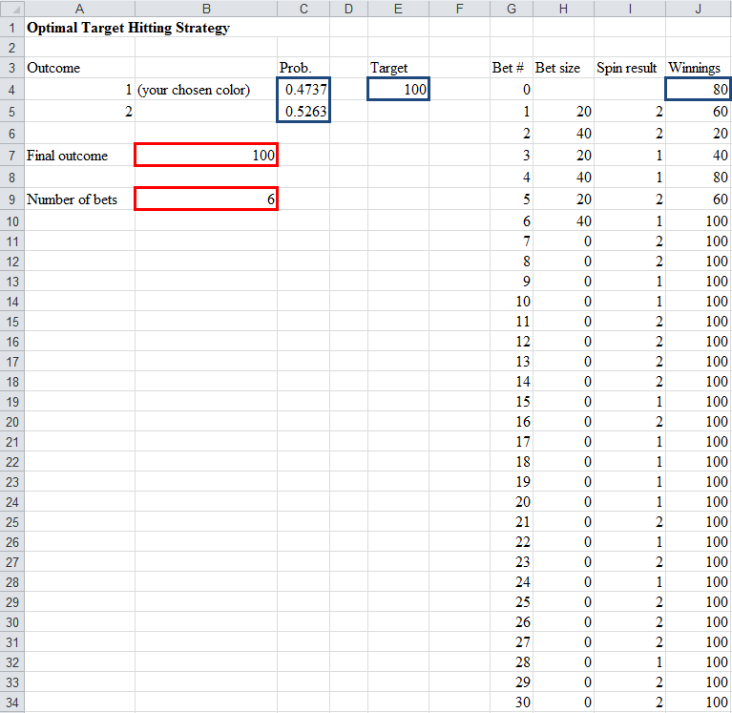Suppose you have $80 to bet and you would like to hit the target of $100. Suppose we focus on the Red or Black bet.

Strategy:

______________________________________________________________________________________________________________________________________________________________________________________________________________________________________________________________________________________________________________________________________________________________________________________________________________________________________________________________________________________________________________________________________________________________________________________________________________________________________________________________________________________________________________________________

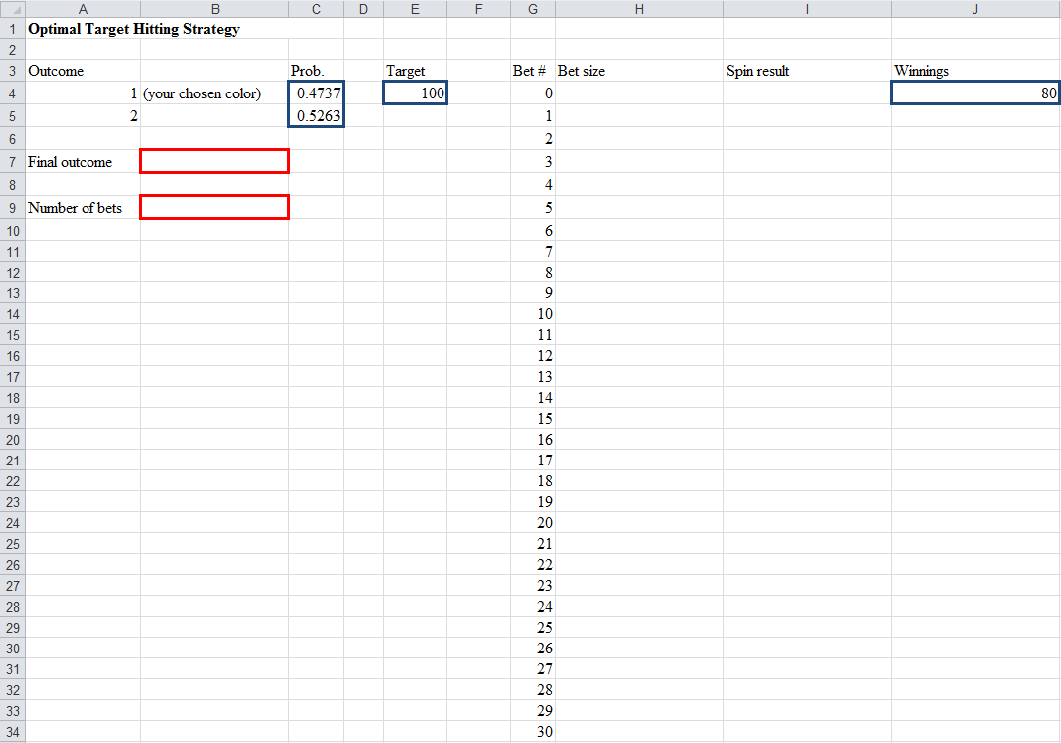**Specify the @Risk Model in Excel:**

What’s the probability of hitting the target?